
Worlington Properties Through Time
Constructing Your Property’s Information Page
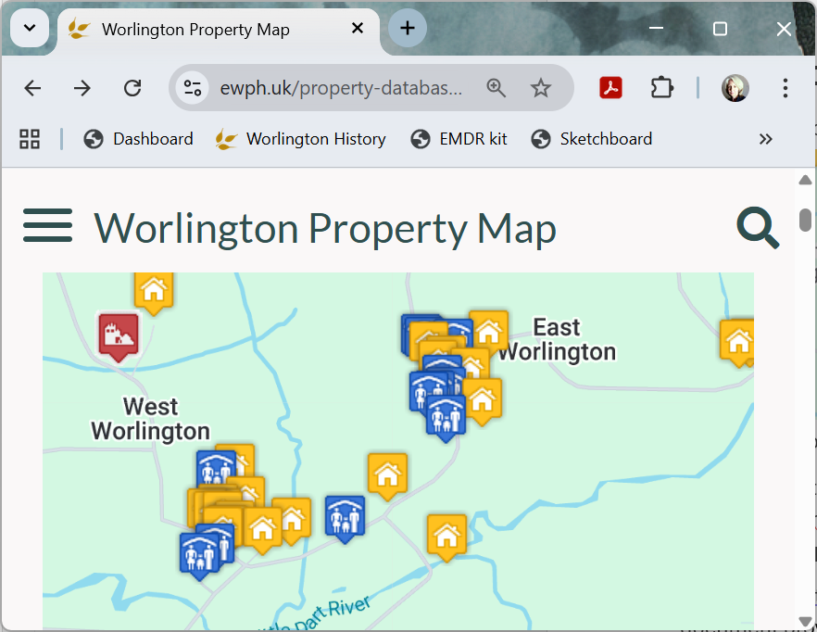
As part of a project to provide census data for all the properties in the parish there is a map of the parish on ewph.uk website.
The Worlington Property Map shows the location of all the properties within the parish of East Worlington.
Clicking on a property takes you to the census information (if available) for that property.
In addition to the census information some of the properties (such as East Worlington House, Affeton Castle and Lower Blagrove) have an information page provided by the owners of the property.
You can also add information about your property and the rest of this document provides a word template you can use as a guide as to what information you could supply.
You can add photos to this document but please also send any photos separately. Ideally the photos you include will be jpg format with a minimum width of 640px and minimum height of 360px.
All profiles should have as a minimum a photo and a description. The remaining sections are all optional.
Please obtain permission if you are including any information about other people or your photographs show other people or properties. The editors of Worlington Properties Through Time will use your information to construct a page for the website and will contact you if any clarification or changes are needed. You will have access to the finished page before it goes live on the website to make any final changes.
Send your finished document to worlingtontimes@ewph.uk.

Enter Your Property Name Here

Property Description
This is where you get to give a brief description of your property.
Your House Photo  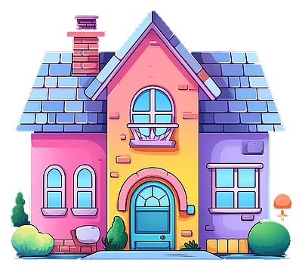 | Description  Put here anything here you want to say about your property. This might include its location, age or construction. Add any interesting features – feel free to include photos - and any historical facts you are aware of.

Stories
Here is where you can tell any stories you have about your property. Submit as many stories as you like. Examples could be The Day the Chimney Fell Down, Famous Artist Lived Here, or maybe something like how your property got its name. Stories should be short and ideally have a picture.
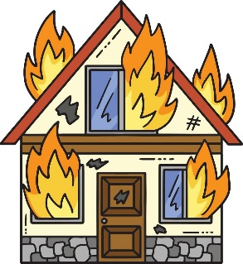Photo for your story

Title: When the House Caught Fire
Story: Enter here a brief outline of your story. The length should be short - think newspaper article rather than War and Peace.

Copy this box to add as many stories as you wish.

Fact File
A fact file is an effective way to present pieces of information you may have about your property and that you want to highlight. For example, you could use this to record changes to the property following a renovation, or simply any interesting facts you have.
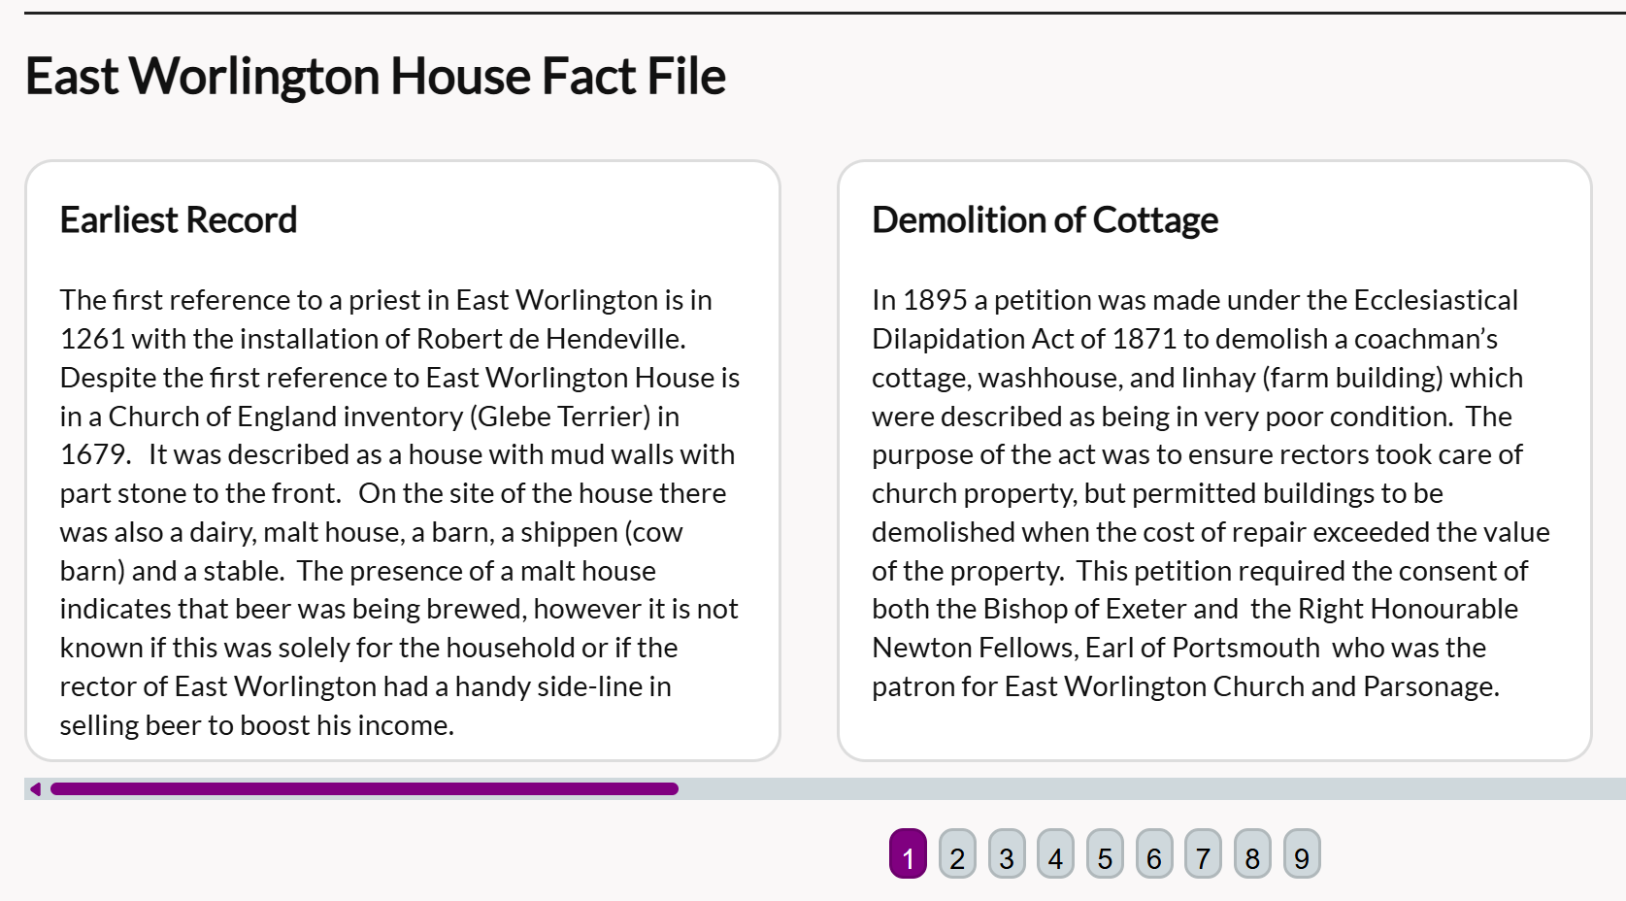
Fact 1 Title | Fact 1 details here – can include images and or links
Fact 2 Title | Fact 2 details here
Fact 3 Title | Fact 3 details here
Add further rows as needed.

Timeline
This is where you can present historical information in date order. You can include any information that can be identified by date. As in the example below, give each item a title and you can also provide additional information which won't be shown on the page but will be linked to (example of this below in Shooting Lodge which links to the Census records page for Affeton Castle).
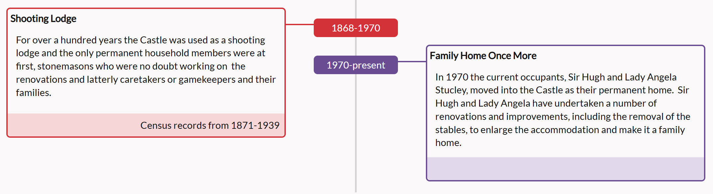
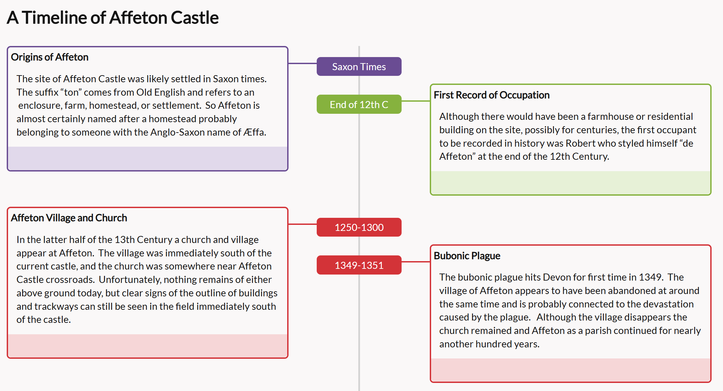
Date 1 | Title for date 1
Information for date 1 here | Web address for more information

Date 2 | Title for date 2
Information for date 2 here | Web address for more information

Date 3 | Title for date 3
Information for date 3 here | Web address for more information
Copy to add further dates as needed.

Press Cuttings
If your property has been in the news, you can highlight it here.
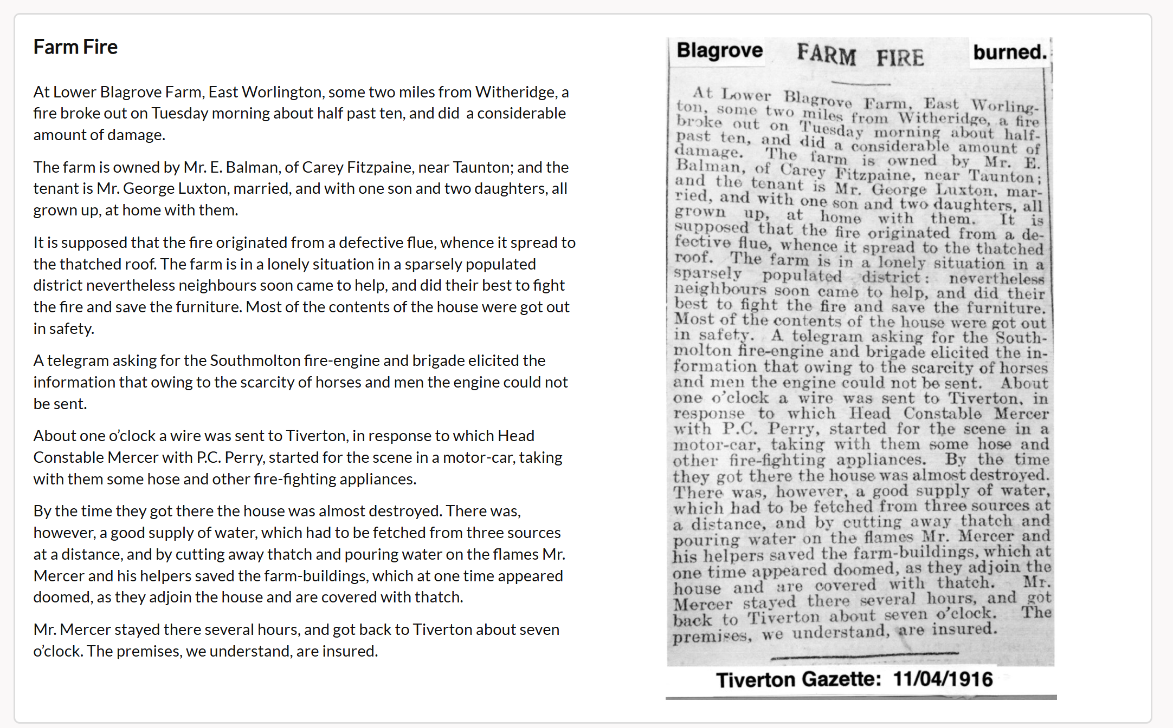
Press Cutting  Attach jpg of your cutting.  Enter here the source and the date for the press cutting. | Description  Put here anything you want to say about the press cutting. If your cutting is hard to read, you might want to provide a transcript here.
Add further rows as needed.

Documents
Here you can add any documents you want to include on your page. These should preferably be in pdf format. It may not be possible to display any other formats.
Document Title | Description  Let people know here what your document is and why you have included it on your page. | Name of file attached to email
Add further rows as needed.

Photographs
You can also add additional photographs of your property. There is limited space for these so choose carefully what you want to display. Ideally the photo will be jpg format with a minimum width of 640px and minimum height of 360px.
Photograph Title | Description  Any here additional information about the photograph. | Name of photo file attached to email.
Add further rows as needed.

Original Artwork
We are lucky to have several talented amateur artists in the parish and some of properties have been painted. These are displayed on the Gallery of Property Paintings section of the website. If you wish to add a drawing or painting of your property, then provide an image along with this template.
Artwork Title | Artist name | Name of artwork file attached to email.

Other Information
You may provide any additional information here that is relevant for your property or attach as a separate document.

Send your finished template, images and any other documents to worlingtontimes@ewph.uk.

