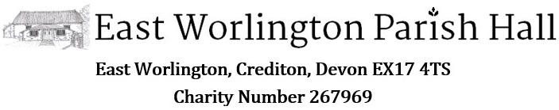

East Worlington Parish Hall - Community Survey 2020
During October 2020 East Worlington Parish Hall Committee held an online community survey to help inform the future business and improvements at the Hall. The Survey Report is shown on the following pages.
Here are some key findings:
- Most favoured regular events:
  - Sunday Brunch – Pub Nights – Quiz Nights
- Annual Events are significantly well supported:
  - Listed in order of definitely attend: Annual Fete - Crocus and Cream Teas - Christmas Lunch - Riverside Music - Harvest Supper.
- Suggestions for additional annual events include:
  - Music and cultural events - Remembrance Sunday Breakfast - Monthly midweek lunch - Easter egg hunt - Conservation or wildlife information talks - Barn dance - walk around Affeton / parish - Bonfire/ fireworks night - Astronomy star gazing course - Xmas wreath making event. Movie and/ or concert/ opera streaming night on large screen - A community run or cycle or bed push followed by refreshments in the hall
- Suggestions for additional activities
  - Examples suggested include: Bingo - Themed Food Nights - Virtual Office for remote workers - antique valuation - Cinema / Film Nights - Wine/Cheese tasting - Cookery demonstrations - theatre or small music performances
- Suggestions for different groups
  - Examples suggested include: Yoga – Tai chi – singing/rock choir - dog agility - art related activities - Bridge club - university of the third age - Reading group - IT skills development - Exercise for the elderly
- Facilities and equipment
  - Generally viewed as good or excellent except Car Parking and Wi-fi
- Website and e-communication
  - Valued as good or excellent
- Main issues for improvement:
  - Improve Car Parking
  - Improve Internet / Wi-Fi connectivity
- Investment
  - A significant number of respondents support the view that investment should support future improvements and savings for future rethatching compared to only resourcing Hall maintenance

Survey summaries
The question titles are part of the chart image.

Tell us about yourself or your household
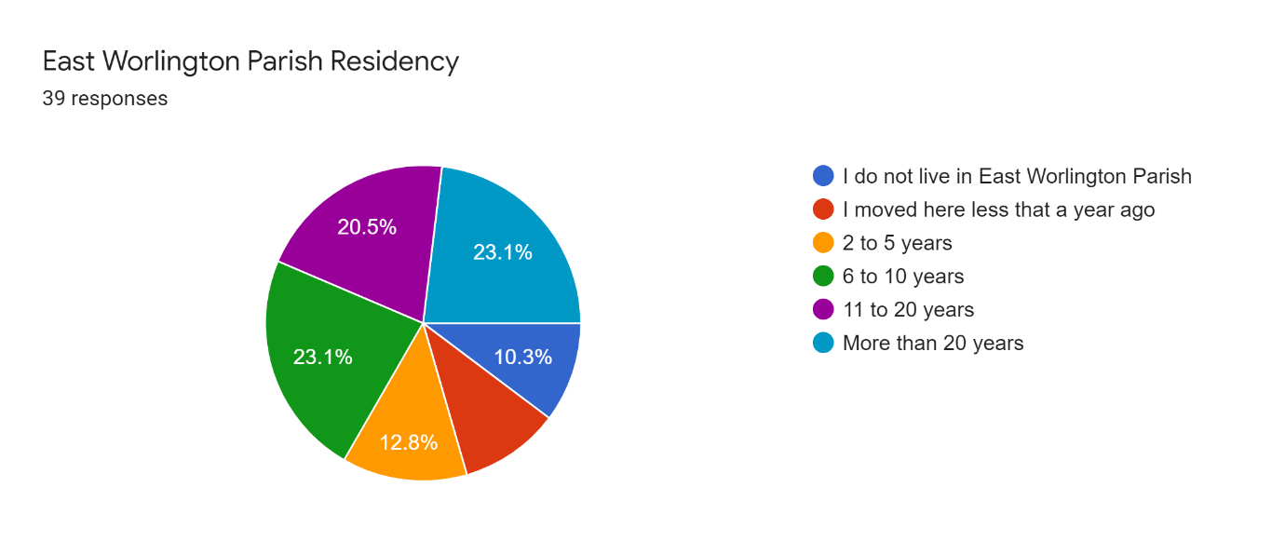
Tell us is if you have any special needs or disabilities that need to be taken into consideration in our planning.
- Not at the moment although Jane has some disability in getting out of chairs
- I need chairs with arms to stand up
- Myself and husband both have older age disabilities such as walking. I have enjoyed community the past 50 years

Hall Events and Activities
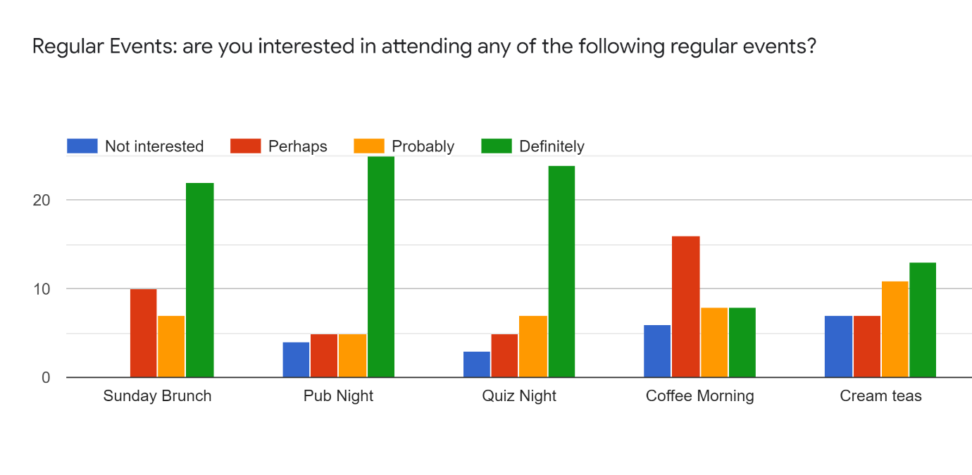
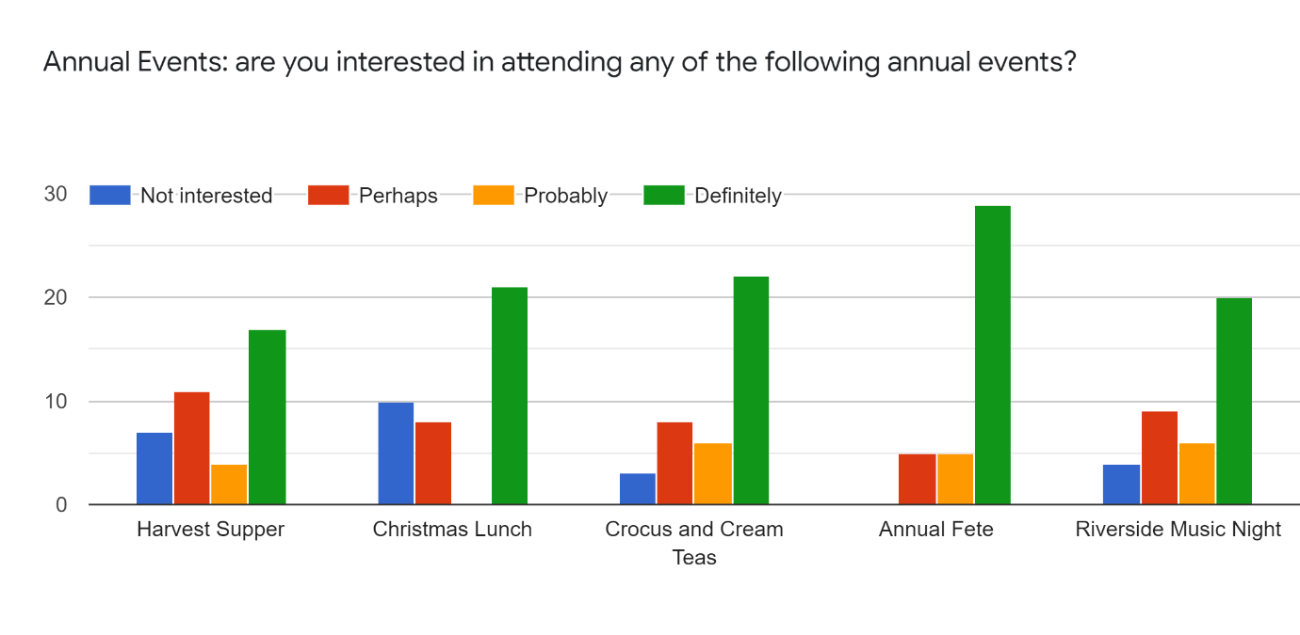
Are there any other annual or regular events you would be interested in attending?
- Music and cultural events
- Remembrance Sunday Breakfast
- Monthly midweek lunch, bingo, produce show, Easter egg hunt, WI or equivalent
- Conservation or wildlife information talks etc
- Film night, Bingo
- Barn dance
- Really enjoyed the walk around Affeton, something similar again for Worlington and surrounding parishes?
- Bonfire/ fireworks night. Easter egg hunt. Astronomy star gazing course. Xmas wreath making event. Movie and/ or concert/ opera streaming night on large screen.
- A community run or cycle followed by refreshments in the hall. I believe there used to be a annual bed push or am I making that up? So something similar but maybe without the beds!!
- Sunday roast. Films
- Live music (popular or classical), stand up comedy or theatrical performances. Talks on nature, environmental issues, architecture and local history. Film nights.
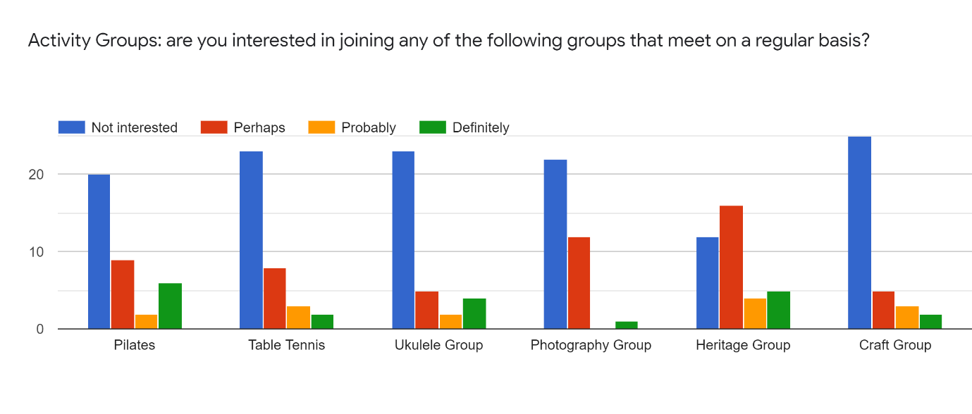
Please suggest any other activities that you may find of interest such as exercise classes, yoga, tai chi, art groups, music groups, or other groups?
- Yoga
- Music Groups
- Yoga
- yoga, singing, dog agility,
- art related activities yoga Rock choir
- Yoga, meditation
- Bridge club, university of the third age
- tai chi
- Art lessons
- Tai chi Pottery and Sculpture
- Yoga - keep fit for seniors!
- Yoga or tail chi, or similar
- Reading group, IT skills development
- Exercise for the elderly. An evening of people displaying their hobbies for fund raising 50/50 sale. Class for particular a tasks with ipad and computers with individual help.
- Choral group
- Yoga, tai chi
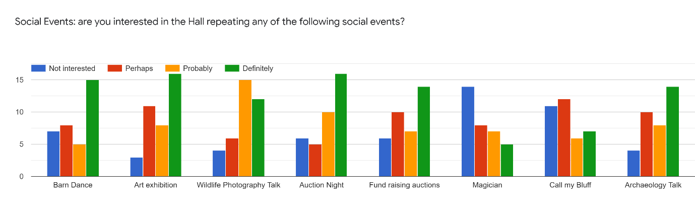
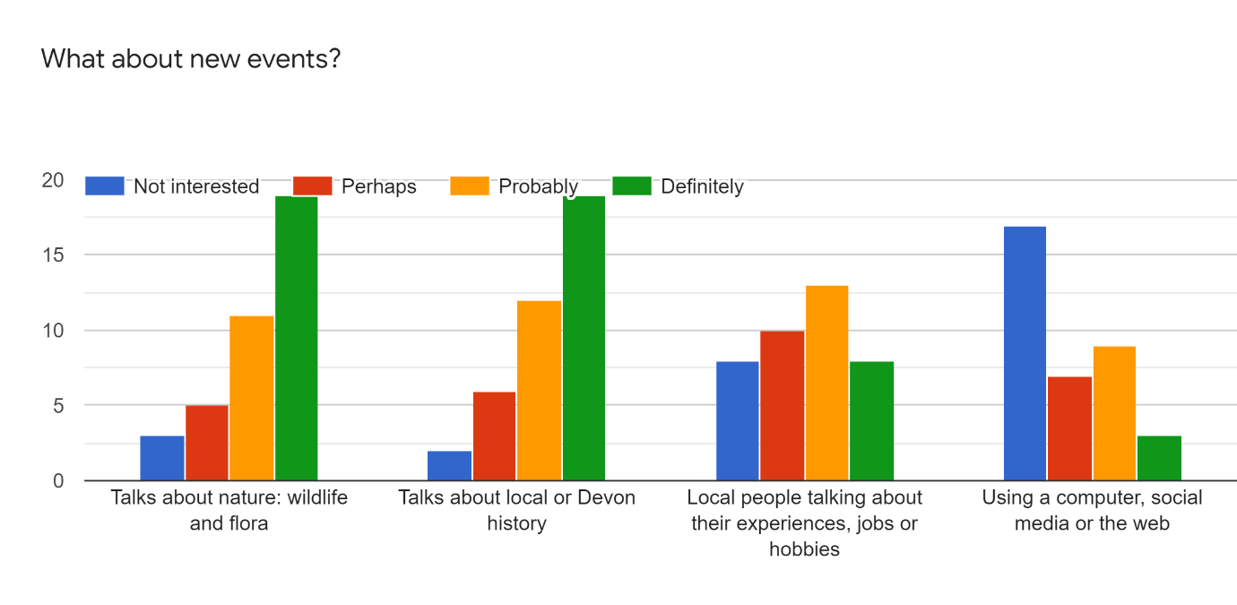
Can you think of any other events we might hold at the hall?
- Bingo
- Themed Food Nights
- Virtual Office for remote workers
- Something for the school or children, antique valuation
- Cinema
- Film/cinema
- Parish Cinema
- Film Night
- Bring and buy with tea and coffee. Starter and dessert evening.
- film nights
- Cinema club? Making use of the audio visual to show arty or classic films.
- Wine/Cheese tasting
- Cookery demonstrations
- As above: theatre or small music performances

Using the Hall
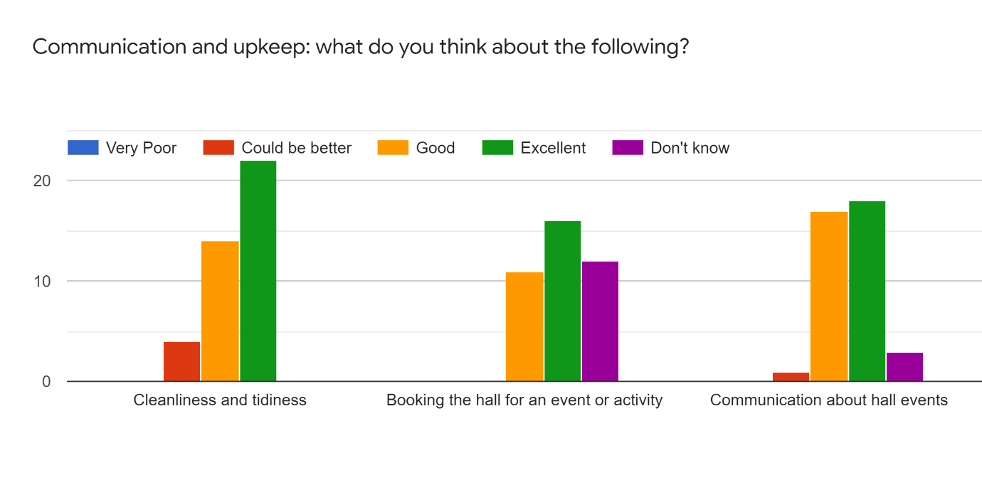
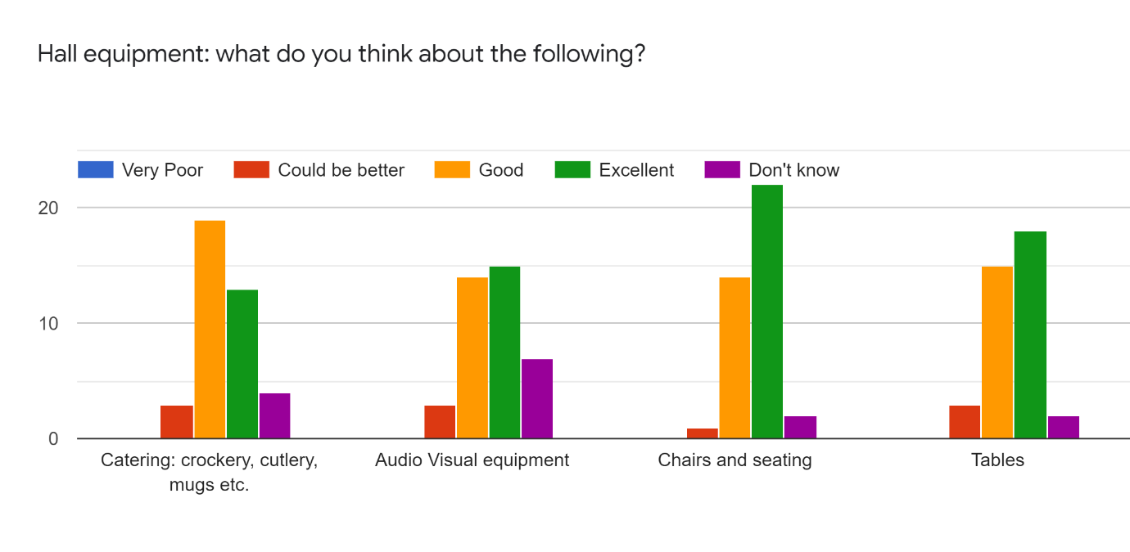
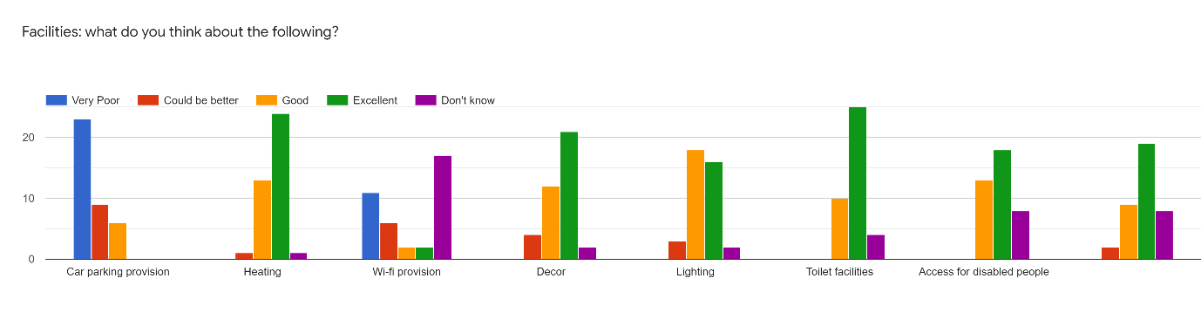
Please expand on any questions where you have answered "very poor" or "could be better" so we can try and improve the situation.
- We are sorting the mugs but the China needs updating to something less heavy
- Lack of parking for social events
- The hall fails as a facility by not providing high speed internet. Fundamentally it cannot be used for civic Emergency or as a virtual office drop in.
- Parking would put me off hiring the hall for a party or family event.
- Wasn’t aware any Wi-fi existed in hall.
- Last time I was there the hall was dirty, particularly the toilets, and the hall floor. The paintwork looked tired. Acoustics are not good.
- needs hard surface car park a short walk from hall so close parking reserved for disabled access/organisers
- wi-fi would help some events, adding femto-cells to allow mobile over IP could address lack of mobile reception in hall
- Not a very large parking area and no WiFi access.
- Need to improve wifi provision to enhance hall's viability ad an emergency centre and some functions
- Parking is adequate but inevitably, at times, congested
- Parking facilities are almost non existent, especially during the primary school term
- The car parking facilities are appalling. There is no guaranteed parking so if you book the hall for a function, especially during the daytime/school term, the chances are you will not be able to park as the current provision is on a first come first served basis. This drastically limits the hall's potential as a money earner.
- A long term solution to the dire shortage of parking would make the hall even more appealing to users, both frequent and occasional
- Stage lighting could be more user friendly / adjustable for the performer
- Lack of parking limits who can hire it. Doesn't affect village events as Campie kindly provides more parking but no good for weddings or parties (which may not be a bad thing?)
- Parking is a problem sometimes but thanks to Campie and Barnabus it has improved a little
- I am sure a lot of people do not go to event's because of the parking
- Limited parking availability... reliant on goodwill of owners of East Worlington House, which is fine under current ownership .... but could be a potentially problem
- Parking needs attention to make use of a good hall. I've heard a few complaints of wi-fi provision
- I have helping behind the scenes and witnessed the cookers under performing and the dishwasher seemed inadequate
- Lack of mobile or WiFi at hall is a problem.
- Reliance on cash method of payment is dated and difficult- recommend a wireless powered mobile card reader.
- Quality of equipment and hall is very high but comes with high pricing for hire which discourages regular use. Also requires hall to be locked which makes it less accessible for community use.
- WiFi provision would be a great addition and would create great potential for playing music at events.
- Car parking - I think you all know the issues here. But massive thanks to the H-B's for allowing continued use of their yard.
- Can't be improved on due to lack of space outside hall. Field parking is good,
- Lack of parking for events in the village Hall is an ongoing problem. Poor WiFi is not currently an issue but may become one in the future.
- I don't think the Parish Hall has any wi-fi

Within the Community
Please rate your level of agreement with the following statements. 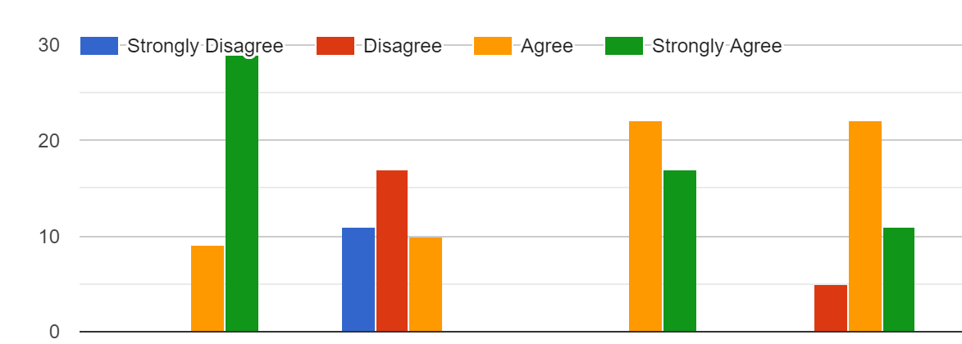
The Hall is a valuable asset to the community | Investment in the hall should only cover essential maintenance | Investment in the hall should cover future re-thatching | Investment should be sufficient to improve the hall facilities

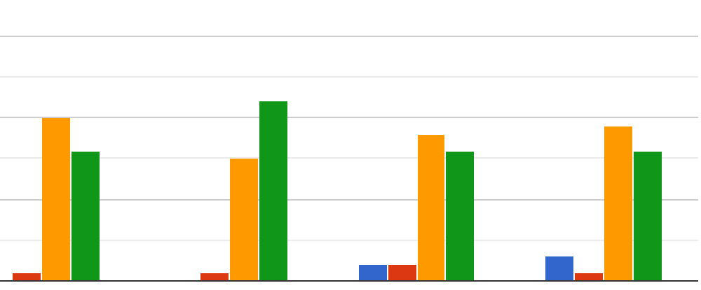
The ewph.uk web site is a useful source of local information | The community emails are a valuable source of information | The Hall is suitable for wedding receptions, christening and wakes | The Hall is suitable for private parties and celebrations

And finally...
Do you have any additional comments you'd like to make?
- Investment in the hall should cover everything.
- Car Parking must be sorted
- It is a wonderful asset for the village and contributes greatly to village life.
- The PH is a considerable asset to the village as a whole, and is a credit to all the people who have dedicated time to it. Awesome.
- I think the hall is great but is reasonably expensive to hire.
- There needs to be an affordable rate to hire the hall for a week or more for longer exhibitions.
- The hall is a great asset as well as being a beautiful building and I would like to congratulate and thank those involved in its development and upkeep
- My young family and I enjoy coming along to the brunch and meeting with the community.
- Venue of choice limited by isolated location, limited numbers due to building capacity and poor car parking
- Parking is an issue which really needs to be addressed.
- With regard to the hall hosting weddings, christenings, parties and the like, the lack of guaranteed parking severely limits its suitability for such events and would put off most people. If I had booked the hall for an function I would not want my guests to have to park in the road and have to walk - especially in winter - to the hall. It is a shame as the hall is superb and could lend itself to these and many other activities.
- It would be useful to investigate the issue of the acoustics
- Just to say thank you to everyone who contributes to the running of the Parish Hall
- All the money raised should have been spent on a new hall with plenty of parking
- I agree if there was better parking for celebrations. Its not nice having to park around the roads and bottom of the hill. My greatest concern is the shortage of parking near the hall.
- thatch on the entrance would be a huge visual improvement
- There is no local shop. Could the hall porch area provide a milk vending machine? Or a book/ magazine exchange?
- It is very important that that the hall appeals to the entire community. Investment in improvement should be weighed against the subsequent requirement to lock hall/ charge users to ensure it remains a community hub for all.
- Question whether hall needs to be locked or can have security code or key lock for community users? And leave some tables or sofas always out for use.
- You are all doing a fantastic job
- Useful survey which should establish what everyone thinks of the hall and how it can be even better used.

