East Worlington Parish Hall
Business and Improvement Questionnaire
East Worlington Parish Hall is a community facility and resource, owned by the Parish Council and leased to the Parish Hall Management Committee who manage the building and hold it in Trust on behalf of the community of East Worlington Parish.
The Parish Hall Management Committee are developing a long term business and improvement plan for the Hall and as a member of the community we would value your views and ideas and like to understand your needs and aspirations in relation to the Hall.
This survey is designed to help with this process by giving you the opportunity to tell us of your views and ideas.
We think the survey will take 10 - 15 minutes to complete: longer if you have a lot to tell us.
The last date for submitting the survey is Sunday 1st November 2020. Once we have analysed all the survey responses we will produce a report and host this on the EWPH website and send out an email with a link to the appropriate page.

Ways to return the questionnaire
- Give to any member of East Worlington Parish Hall Committee
- Post to Steve Baber, Chair Parish Hall Committee, East Worlington Parish Hall, East Worlington, Crediton, EX17 4TS
- Scan and email to: survey@ewph.uk

Tell About Yourself
Please tell use your Name and Email Address so we can enter you into the prize draw.
The prize draw will be for two bottles of wine (red or white - your choice) or non-alcoholic sparkling drink. We'll provide a second and third place draw as well.
Your Name (optional):

Email Address (optional):

East Worlington Parish Residency (please check appropriate option):
- I do not live in East Worlington Parish
- I moved here less that a year ago
- 2 to 5 years
- 6 to 10 years
- 11 to 20 years
- More than 20 years

Tell us is if you have any special needs or disabilities that need to be taken into consideration in our planning.

Hall Events and Activities
In recent years we have held many events at the hall and we would like to know which types of event you would be interested in attending in the future.
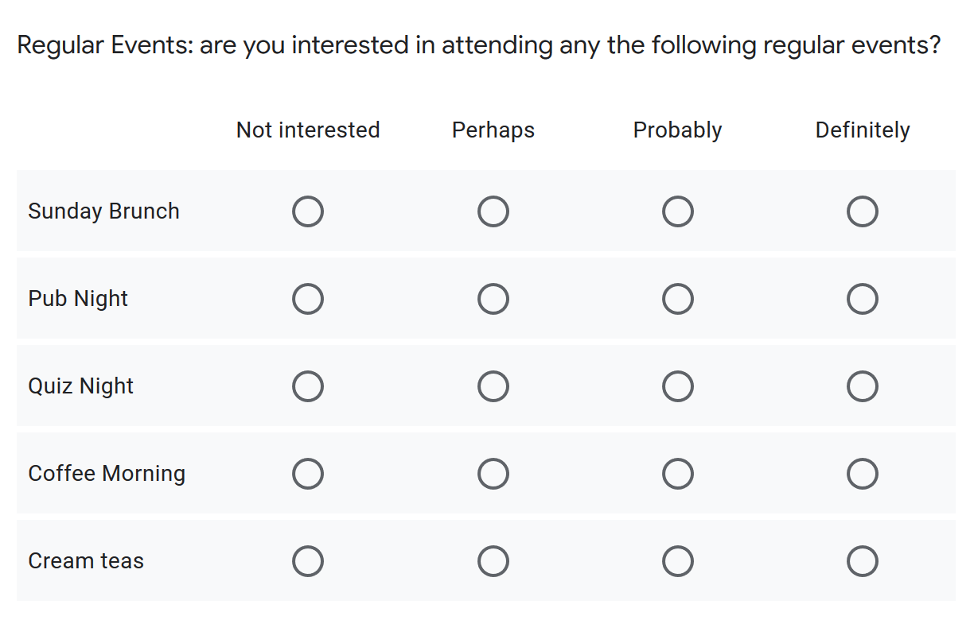
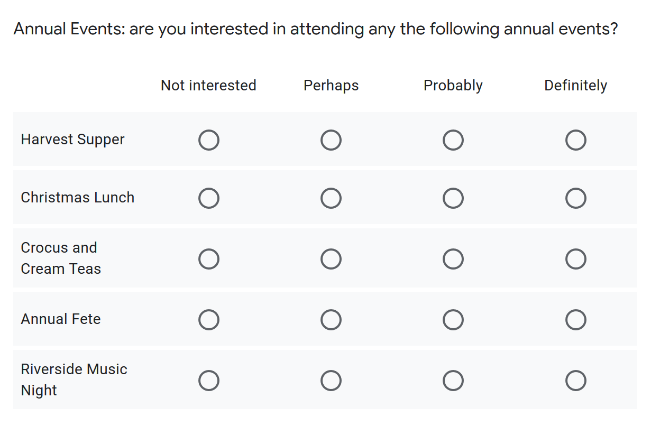
Are there any other annual or regular events you would be interested in attending?

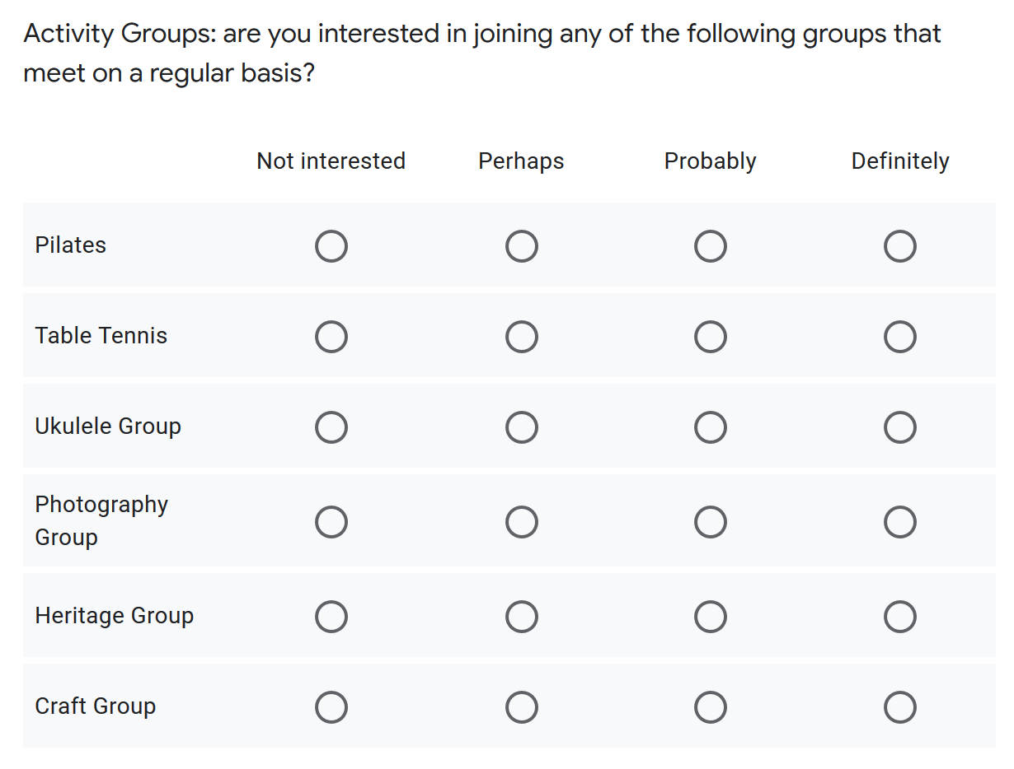
Please suggest any other activities that you may find of interest such as exercise classes, yoga, tai chi, art groups, music groups, or other groups?
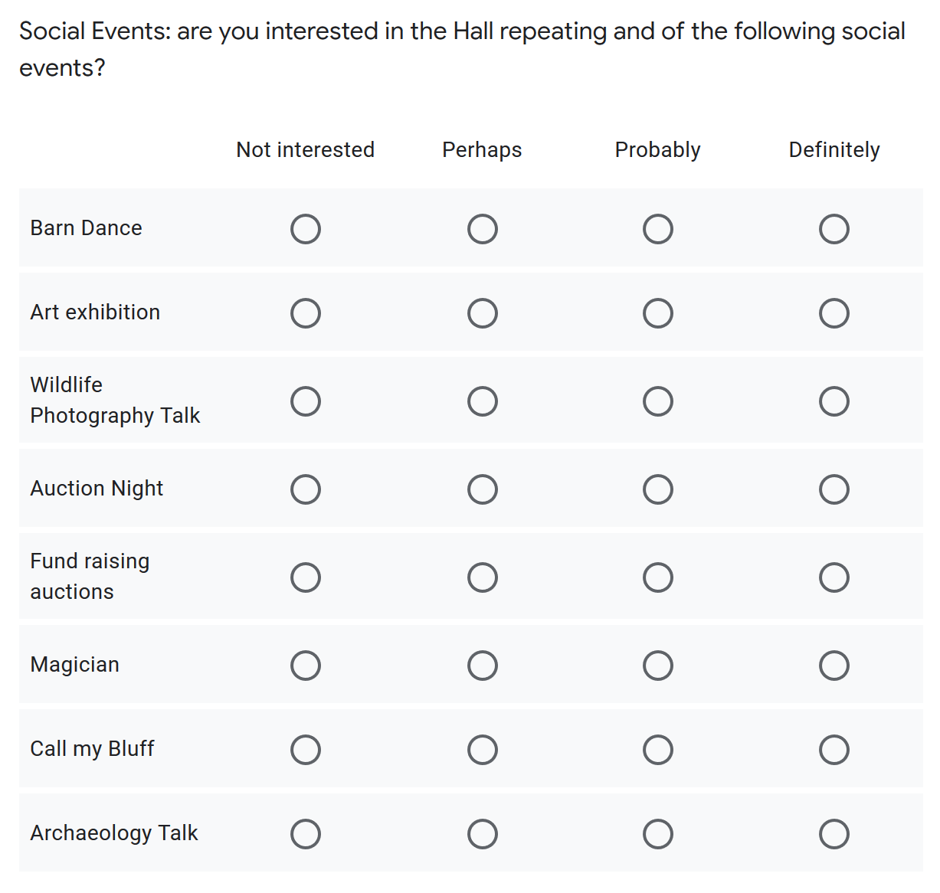
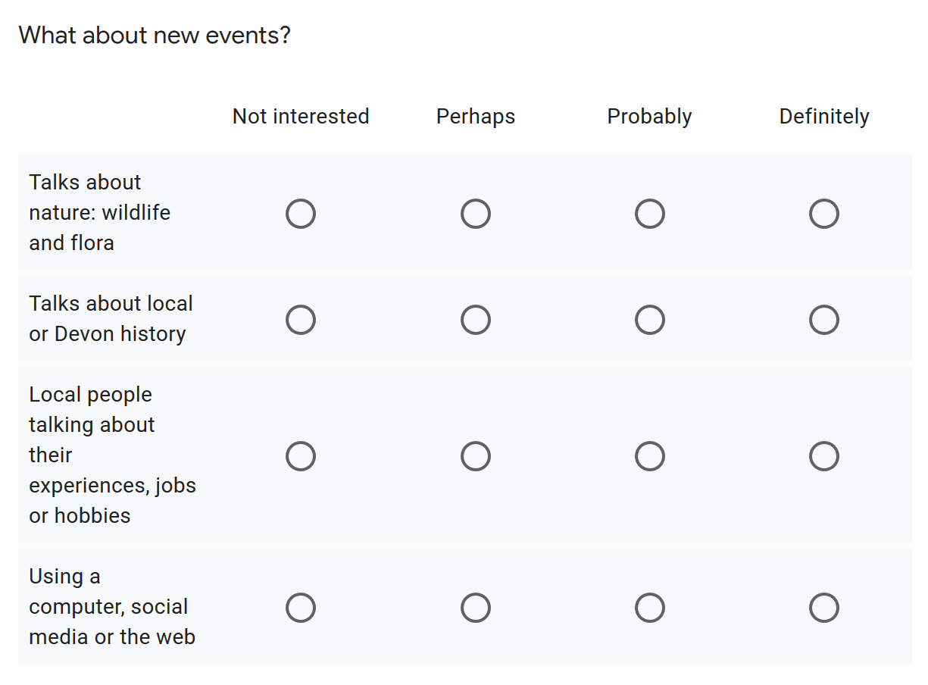

Can you think of any other events we might hold at the hall?

Would you be willing to organise an event (with help from the committee), if so what would you suggest?

Using the Hall
If you have been to the hall for an event please tell us about your views about the overall appearance as well as the facilities.
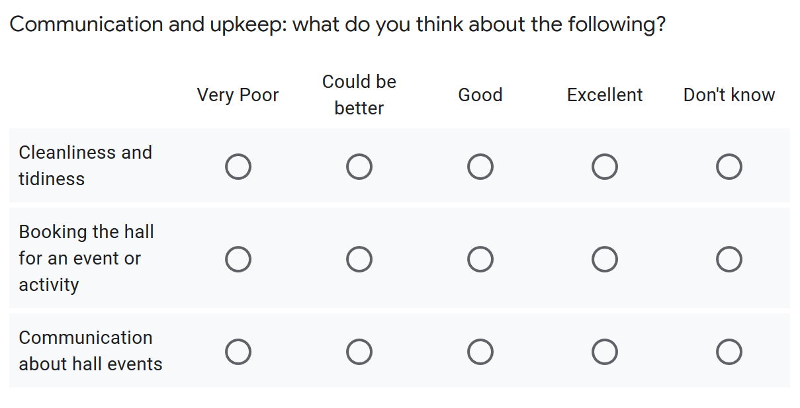
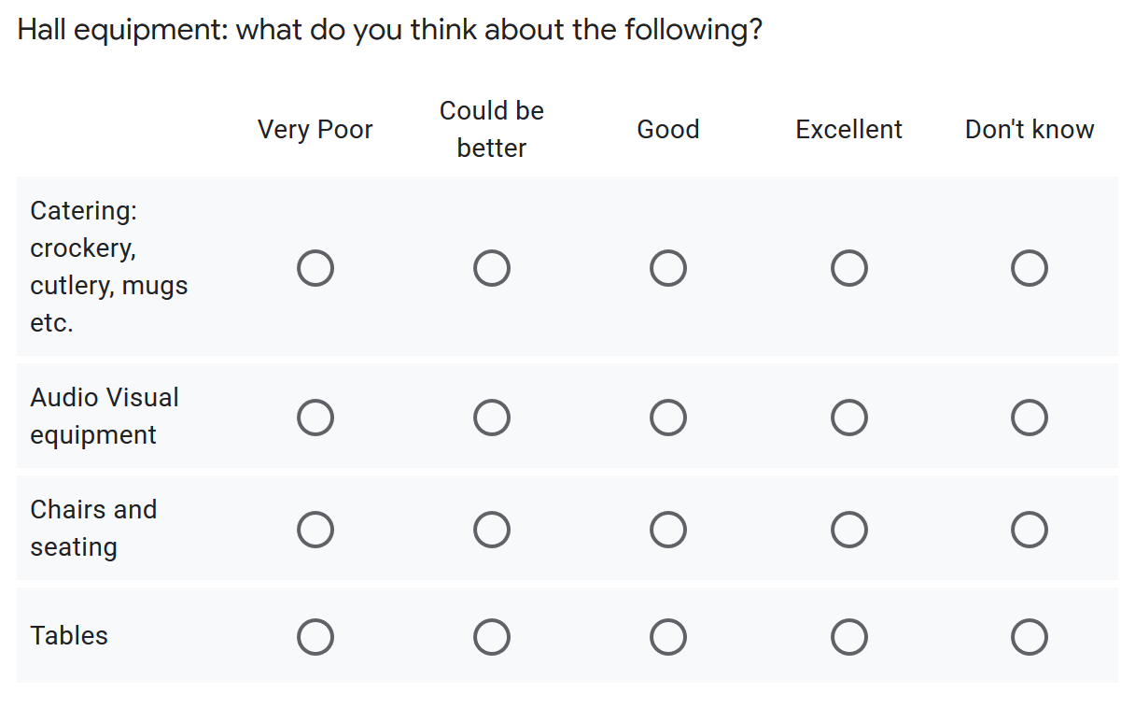
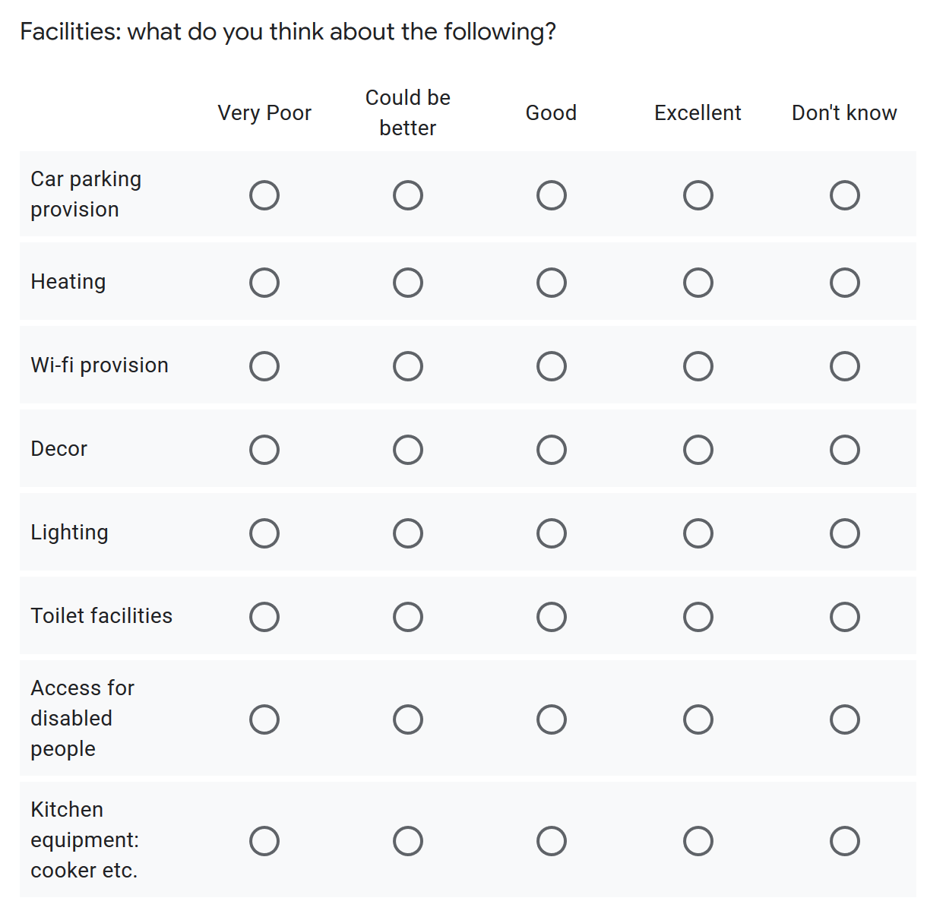

Please expand on any questions where you have answered "very poor" or "could be better" so we can try and improve the situation.

Within the Community
Please tell us about your opinions on the role of the Parish Hall within the community.
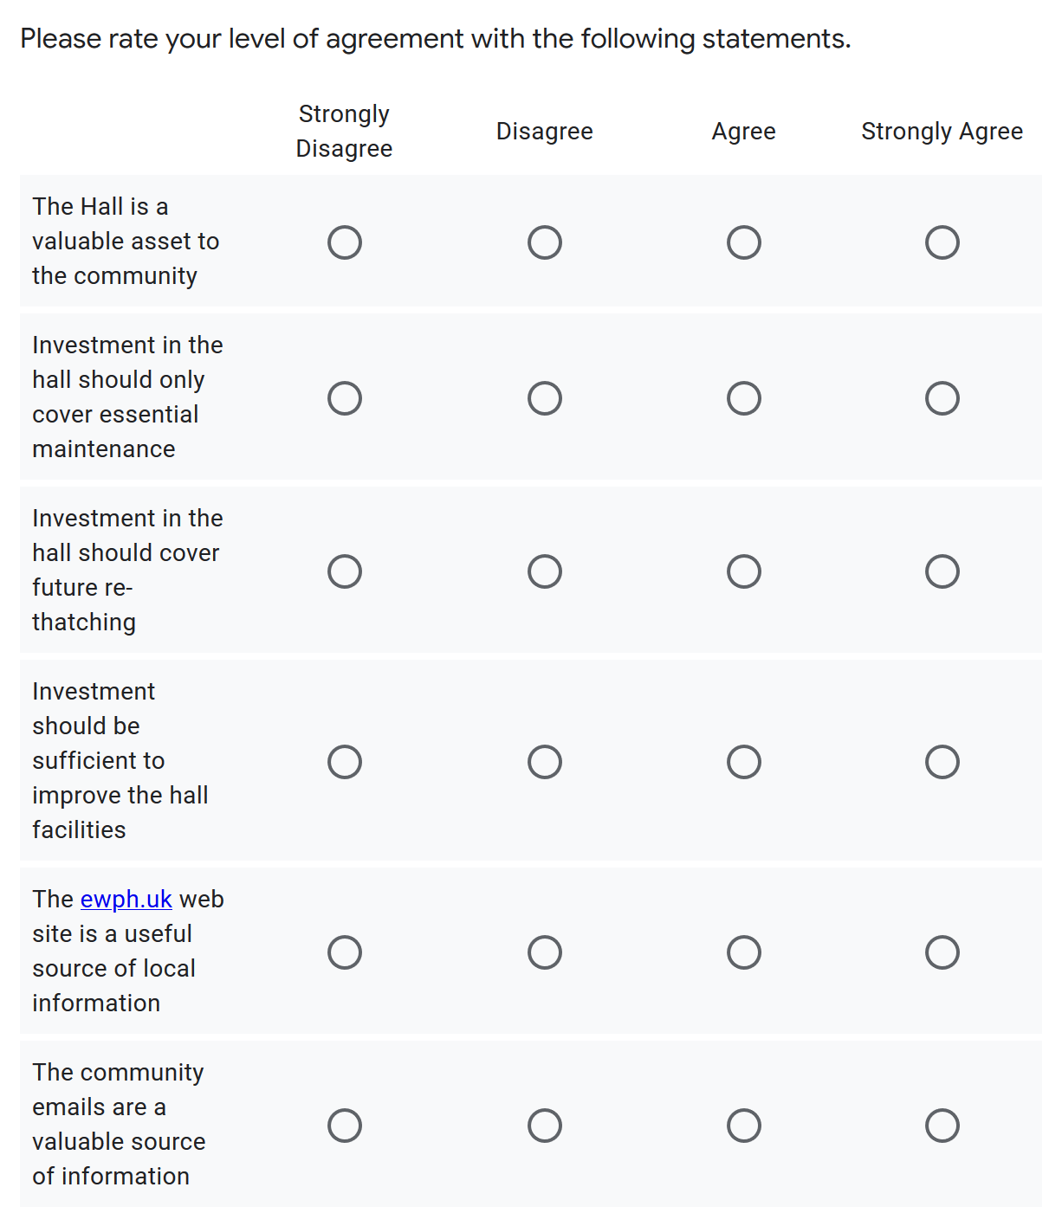

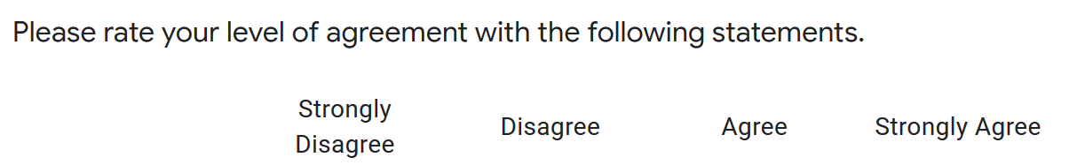
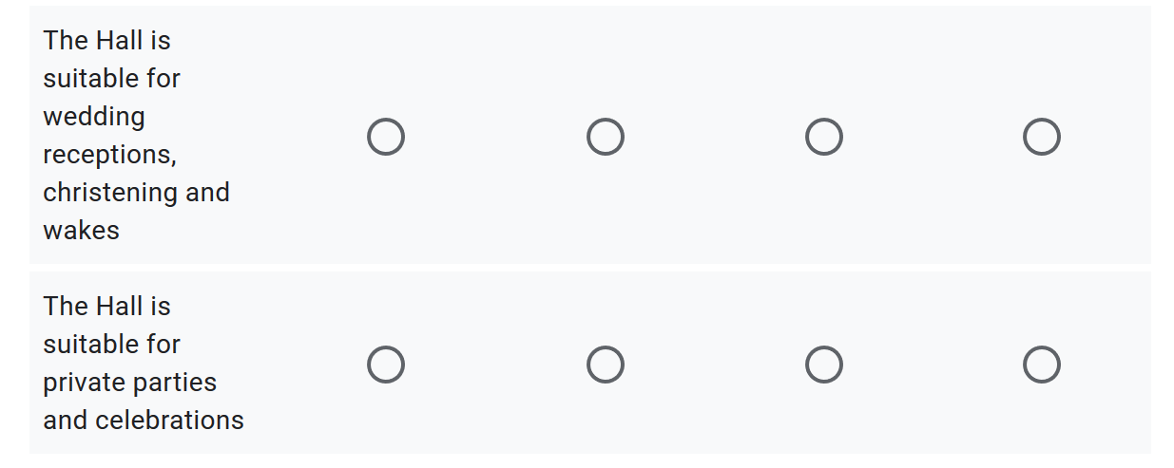

And Finally…
Do you have any additional comments you'd like to make?

To submit your responses please do one of the following
- Give to any member of East Worlington Parish Hall Committee
- Post to Steve Baber, Chair Parish Hall Committee, East Worlington Parish Hall, East Worlington, Crediton, EX17 4TS
- Scan and email to: survey@ewph.uk

