MINUTES OF THE EAST WORLINGTON HERITAGE PROJECT GROUP MEETING HELD AT TOWN FARM BARN 3rd FEBRUARY 2015 AT 7.00 PM

Present: Steve Baber (Chair), Miya Bond, Sandy Haughton, Liz Guppy, Gavin Manton, Lorna Manton (minutes), Philip Risdon

 | ITEM | ACTION
1 | Approval of Minutes of Meetings of 12th January 2015  The minutes were approved as drafted and signed by the Chair.
2 | Matters Arising  Heritage Lottery Fund Update  SB & Martin Bond attended a Heritage Lottery Fund monitoring meeting. This was an informative workshop and provided valuable information about the financial aspects of the project and the reporting systems required by HLF.  The workshop clarified that the VAT identified in our project plan was a discrete element of the grant and that element could only be used to pay VAT requirements. The Heritage Lottery Fund grant for the Heritage Project is £58,000 + £7,200 for VAT.  Work is under way to clarify the extent to which VAT on elements of our project can be zero-rated or charged at the full amount.  Heating - The system, whether oil or air source, has not yet been decided. Further meetings being undertaken & quotes obtained.  Fund Raising - Judith Kauntze has obtained a donation of £10,000 from Viscount Amour Trust. This has reduced the dependency on local crowd funding which is now pledged at £4,000.  Heritage Project Blog  Martin B working on new blog. All of Group can use and MB will give instructions. SB to put link on web for Heritage Project Group Minutes. LM to then action. | SB & MB  SB  LM
3 | Heading and Logo (Website)  SB explained and showed to the meeting the 3 elements that were required for the new website header, namely  - Name – East Worlington Parish Hall  - Image – Drawing of hall  - Logo – Drawing of leaves above the ‘I’ of the word Parish  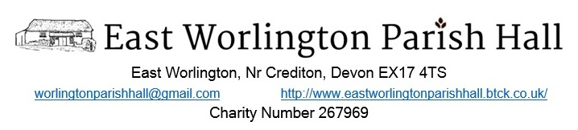
4 | Heritage Project – School Engagement Element  LG and SH had a preliminary meeting at EWPS who were looking forward to engaging with the project. It is anticipated that children will concentrate on the development and history of the village incorporating a timeline, mapping skills, information gathering etc.  PR will attend a meeting with LG & SH at EWPS on 24.2.15. | LG, SH, PR
5 | Heritage Project Launch Planning  SB circulated a draft plan which all endorsed. However it was agreed:  - The presentation will be reduced to 30 minutes  - Powerpoints will be used to enhance the presentation  - A question & answer session will be held after attendees have had an opportunity to discuss the Project following the end of the talk.  All members of the Heritage Group should wear the blue badges which had been provided by the Heritage Lottery.  Brian Edwards had also kindly agreed to supply beer for the launch.  It was agreed SB should call an Extra-ordinary Parish Hall Committee Meeting on 19.2.15. to ensure the Committee were fully briefed about the developments with the Heritage and Parish Conservation Project and any necessary decisions made prior to the community event advertised for Friday 27th February. | SB  SB,MB,LG,SH,LM,GM,PR  SB
6 | Community Questionnaire about dwellings  Amendments were made to the draft (see attached). The questionnaire to be handed out at the Project Launch.  Under the Data Protection Act individuals and organisations that process personal information need to register with the Information Commissioner's Office (ICO), unless they are exempt. LM to ascertain if the Group needs to register in respect of information they are hoping to obtain for the publication of a ‘History of Worlington’ book and action if appropriate. | LM
7 | Any Other Business - Chair’s 2p Challenge  PR agreed to make a sign indicating progress of 2ps that had been received in respect of the Chair’s Challenge. | PS
 | The meeting closed at 8.30 pm

