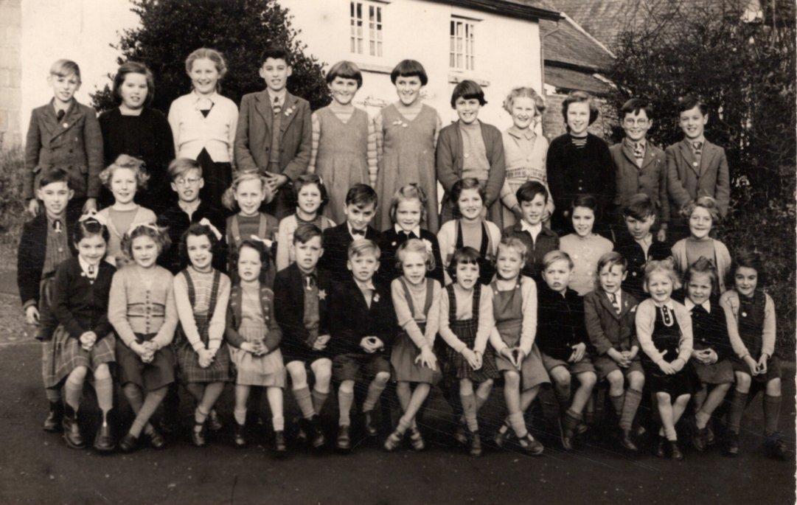
1
2
3
4
5
6
7
8
9
100
11
24
35
25
26
27
28
29
30
31
32
33
34
37
36
12
15
16
17
19
20
21
22
13
14
23
18
1 | Michael Roe | 14 | Rodney Phillips | 27 | Ruth Wright
2 | Daphne Phillips | 15 | Meta Fewings | 28 | Stephen Troakes
3 | Maureen Ayre | 16 | Sylvia Cole | 29 | Brian Lovell
4 | David Cole | 17 | John Cox | 30 | Gillian Cox
5 | Ruth Troake | 18 |  | 31
6 | Mary Troake | 19 | Julie Keenor | 32 | Angela Payne
7 | Stephanie Cox | 20 | Alan Govier | 33
8 | Marcia Stoneman | 21 | Eileen Harris | 34 | Aubrey Harris
9 | Heather Kirslake | 22 |  | 35 | Lorna Venner
10 | Cyril Harris | 23 | Mavis Stenner | 36
11 | Raymond Govier | 24 |  | 37 | Barbara Cole
12 | John Troake | 25 | Christine Jenner
13 | Sheila Stenner | 26 | Heather Wright

